**Computer Enrollment Invitation For JAMF**

1. Access the link:-  [https://zumigo.jamfcloud.com/enroll?invitation=23946065230893809537682169493529095093](https://zumigo.jamfcloud.com/enroll?invitation=23946065230893809537682169493529095093" \t "_blank)
2. Click on Continue

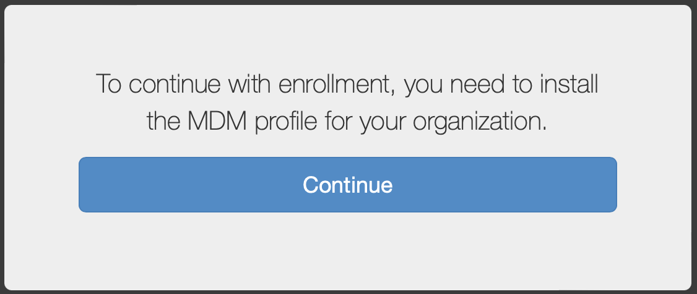

1. Click on Keep.

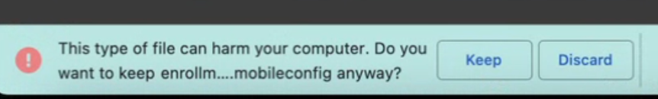

1. Double click on the downloaded file.

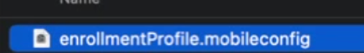

1. This window will pop up.

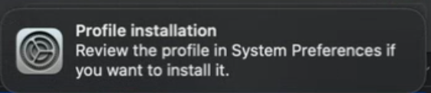

1. Choose Apple menu > System Preferences, you will see the following new logo.

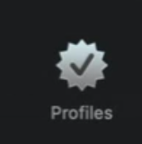

1. Double click on it and Then Install

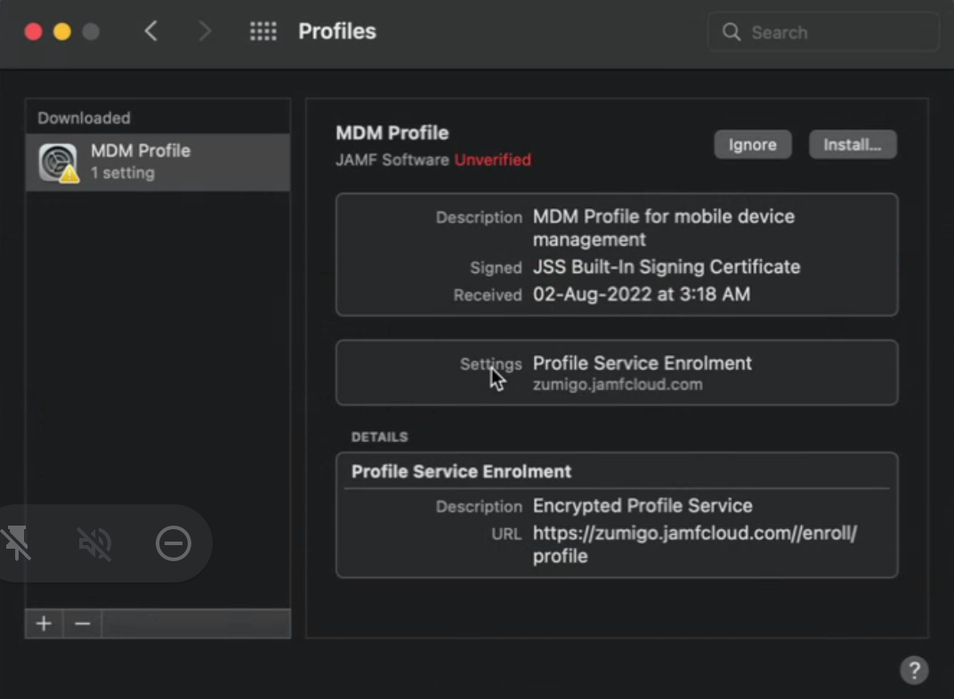

1. It will ask for the some MDM profile to install. Once you get the pop up please click on install

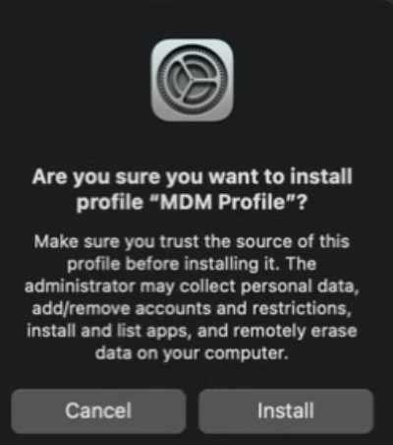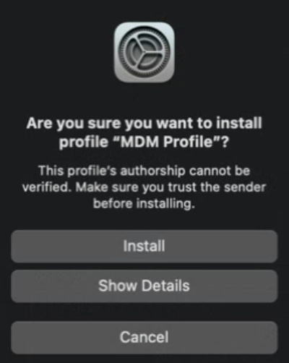

1. Enter your MacBook laptop password.

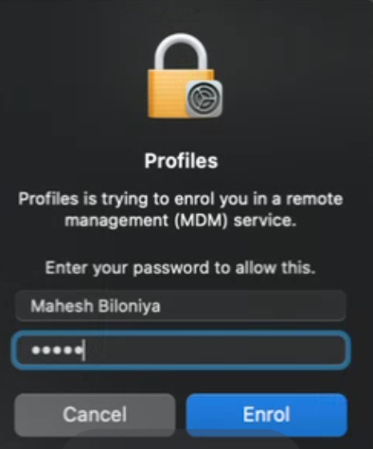

1. You will see this screen. It will take a few minutes to verify.

